SAMPLE WARRANTIES
Door Corner Construction

Limited Lifetime Warranty


A Division of Coral Industries, Inc.

ARCHITECTURAL PRODUCTS

Customer: _______________________________________
Project: _________________________________________
Effective Date: ____________________________________
Architectural Firm: _________________________________

This Warranty is in addition to Coral Architectural Products (Seller) standard two (2) years limited warranty and is wholly and exclusively applicable to Seller’s factory fabricated and assembled aluminum entrance door’s dual moment corner construction.

The Seller warrants to its dealers, customers, and all subsequent purchasers and users that its dual moment corner construction assembly shall be free from defects in workmanship and materials for the normal and useful lifetime of the door.

This warranty is effective from the date of substantial completion of the project provided however that the Limited Warranty shall begin in no event later than 6 months from date of initial shipment from Seller’s factory and applies only if Seller’s doors have been installed and maintained in strict accordance with Seller’s published recommended practices and installation instruc- tions and only if Seller is notified in writing within sixty (60) days after such defects appear.

Seller’s obligations under this warranty are limited to the repair or replacement of any defective door and/or the refund by the Seller of the original purchase price paid for the door and does not include the replacement of glazing in-fills, gaskets, hardware, doorframe or adjacent framing temporary enclosures, nor any installation charges, labor charges, delivery or freight charges.
The Seller reserves the exclusive right to select one of these remedies.

Seller hereby disclaims all Liability for any door that has been subjected to abuse, alterations, modifications, neglect, misuse, abnormal use, accident, fire, war, flood, earthquakes, Acts of God or damage caused by parts not furnished by Seller.

In no event will the Seller be liable for Direct, Indirect, Special or Consequential Damages including, but not limited to, Loss of Profits or Good Will, Loss of Use or Other Commercial Loss or Injury. Seller further hereby disclaims all liability for the installation of Seller’s doors. Seller makes no other Representations or Warranties, Express or Implied, including but not limited to any Implied Warranty of Merchantability or Fitness for a Particular Purpose.

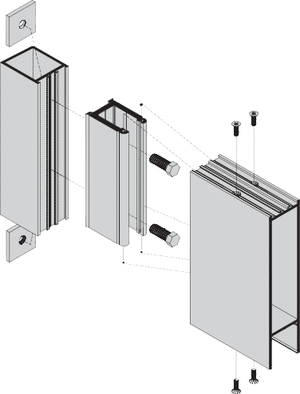
Warranty claim may be filed by notifying Seller in writing within sixty (60) days of defect discovery at: Warranty Claim Office

Coral Architectural Products
P.O. Box 40228
Tuscaloosa, AL 35404-0228 Coral Architectural Products
Representative

Customer Service Manager To Be Advised
Title Date

GI-6
www.coralap.com
March 2017

